Producer (freelance)
Dear Applicant,

Thanks for your interest in being 201 Dance Company’s new Producer

There are 2 documents to read and complete:
- this recruitment pack
- the equal opportunities form. The equal opportunities form will be kept separately from your application.

201 Dance Company are an equal opportunities employer. We particularly welcome applications from people of colour or people who identify as D/deaf or disabled as they are currently underrepresented in the arts. If you feel you meet all the requirements of the role but have difficulty applying due to access obstacles, please get in touch to discuss how we can make the process accessible for you.

This role is open to applicants living in any area of the UK.

If you have any questions, would like this information in a different format, or would like to discuss access requirements, please get in touch with Andrea Walker on info@201dancecompany.com.

To apply, please send
  - a CV,
  - an equal opportunities monitoring form,
  - and a cover letter of no more than 500 words outlining why you think you would be suitable for this role
to Andrea at info@201dancecompany.com.

Deadline for applications:
Please send your applications by email by 12 midday on the 3rd of May 2022.
Interviews will be held starting the 4th of May, over Zoom.
We wish you all the best in your application to join us at this exciting time.

Best wishes,

Andrea Walker
Artistic Director

Overview of the Role

General Scope: Working with the Artistic Director, lead on the producing, tour-booking, and fundraising for all 201 Dance Company productions.
Initial Scope of this contract: Working with the Artistic Director and with handover and support from the outgoing producing team where needed, produce an Edinburgh Fringe Festival run of 201’s “Sad Book” - adapted from the award-winning novel by Michael Rosen - and book a tour for this production. The Edinburgh Fringe run will take place at Zoo Main Stage from the 22nd to the 28th of August 2022.

Employment type: Rolling freelance contract.
Initial contract of 20 days over 5 months, roughly 1 day per week. Future contracts dependent on successful fundraising.

Fee £170 per day. Initial contract fee £3,400 for 20 days’ work.

Hours: Flexible working hours.

Work location: This is a remote-working contract.

About 201 Dance Company

“This is the new generation of street dance” – The Times

201 creates dance-theatre productions that are accessible, socially responsive and challenge prejudices. Our work brings stories of queer, trans and immigrant experience and mental health to diverse audiences.

Since 2015 our UK tours of ‘Smother’ and ‘SKIN’ have reached over 17,000 UK audiences in over 30 venues (“one of the year’s finest treats” - Huffington Post). We’re now adapting Michael Rosen's "Sad Book", commissioned by Everyman Cheltenham and supported by The Old Market, exploring depression and incorporating digital animation.

International work includes commissions by Joffrey Ballet to create ‘HOME’, exploring queer immigrant experience, which played to over 20,000 people with nightly standing ovations in Chicago (“Hauntingly Effective” –Chicago Sun Times).

Our digital work and outreach workshops have reached thousands of participants, exploring our fusion of dance styles, storytelling in dance, and queer experience in dance.

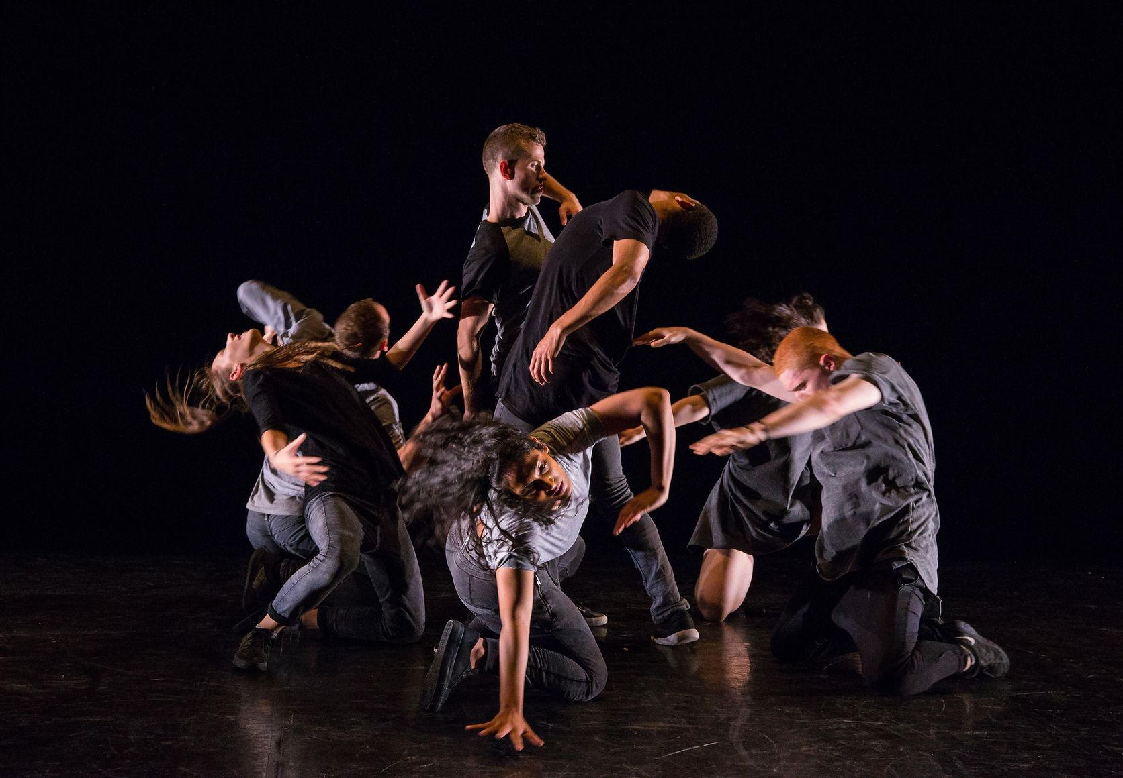

Producer - Job Description
Scope

Working with the Artistic Director, lead on the producing, tour-booking, and fundraising for all 201 Dance Company productions.

Key Responsibilities

Produce 201 productions. This will include:

- Working with our Artistic Director to produce our new productions (usually one new production every 2 years).

- Fundraise for all new productions, tours of existing productions, and outreach programmes. This will include leading on ACE project grants, and actively seeking out commissions, partnerships, and co-productions with venues and festivals.

- Support relationship building with partners and venues.

- Tour booking for existing and new productions, including:

  - Actively seeking platforms for touring and presentation of our productions, including festivals.
  - Actively developing partners who could support touring.
  - Negotiating fees, guarantees, and box-office splits with venues and festivals.
  - Optimising touring schedules.
  - Developing international touring platforms and partnerships.
Existing tour-ready productions include:
  - “Sad Book”:
  - “SKIN”:
  - “Smother”:

- Lead on the marketing and audience development of all productions, including:
  - working with PR consultants (usually Kim Morgan PR) to generate press publicity and reviews.
  - supporting the Artistic Director with social media marketing.
  - overseeing the production of print and digital marketing content, including flyers, posters, social media assets, and online ads where appropriate.
  - Liaising with venue marketing teams to develop marketing campaigns for productions.

- Managing production logistics and schedules.

- Tracking budgets and production spends, working with the Artistic Director to submit project funding reports.

- Support the Artistic Director with the recruitment of creatives, designers, performers and crew.

- Support the Artistic Director to manage contracts with staff and partners.

Support the strategic development of the company. This will include:

- Responding to funding or commissioning opportunities where appropriate.

- Strategizing on the development of new outreach work and new community-based work.

- Seeking out new touring and Artistic Development opportunities, including R&D commissions.

- Ensure the company continues to work with, and reach, a diverse range of diverse artists, audiences, and participants.

- Ensure the company responds to ACE’s Investment Principles.

Person Specification

Essential
You must:
- have experience of producing in a similar or related role.
- have knowledge and experience of fundraising for the arts, ideally with Arts Council England project grants.
- have experience of tour-booking or managing relationships with venues and festivals.
- have a pro-active, flexible, patient and kind approach to work.
- have great attention to detail.
- have excellent written and verbal communication skills.
- be interested in theatre or dance.

Desirable
It’s not essential, but it might be helpful in the role if you:
- have experience or interest in dance.
- have experience with Edinburgh Fringe Festival.
- have some experience in marketing or social media for touring productions.

Application process

To apply, please send your CV, cover letter, and equal opportunities form to Andrea at info@201dancecompany.com.

Application Deadline: 12 midday, 3rd May 2022.

Equal Opportunities

201 Dance Company strives to be an Equal Opportunities employer and we encourage applications from all sections of the community.
We particularly welcome applications from people who identify as D/deaf or disabled and from people of colour, as they are currently underrepresented in the arts.
Applicants are encouraged to complete an Equal Opportunities Monitoring Form, which forms a part of the recruitment pack. This will be kept separately from your application.

Accessibility

If you require this information in an alternative format, please email info@201dancecompany.com

